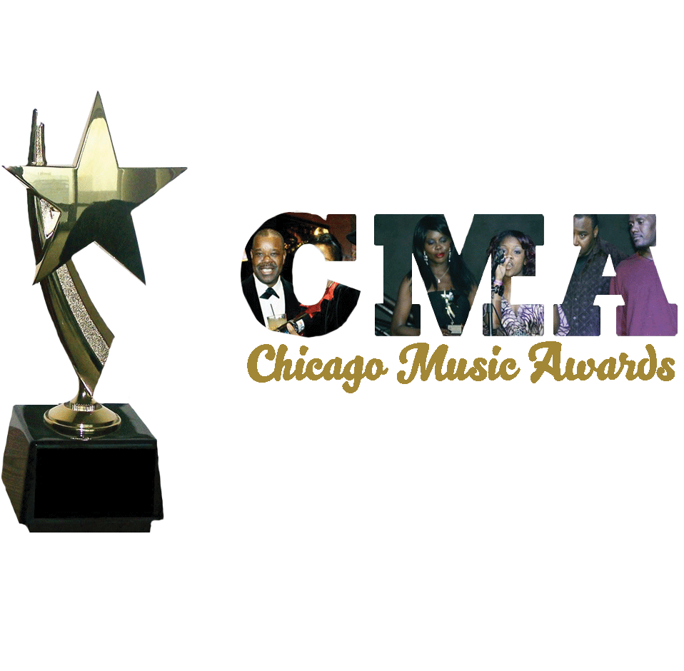
.
41st Annual Chicago Music Awards (CMA)
DATE ADVANCED TO SEPTEMBER 30, 2023
WWW.CHICAGOMUSICAWARDS.ORG

The 41st Chicago Music Awards (CMA) - Sat., September 30, 2023, at the _Harold Washington Cultural Center, Chicago.

Dear Chicagoland Entertainers, Music Industry Members and Experts:

Thanks for your years of contributions in helping us to select nominees for the annual Chicago Music Awards (CMA). Again, you are called upon to help in the selection of nominees for this 41st Annual CMA’s. If you are a new expert/entertainer, we welcome you!

Your decision must be based on entertainers who lived within the 200-mile radius of Chicago for at least one year. Other determining factors include music sales (i.e., records/CDs/DVDs, etc.), originality, social relevance of material, local/national performances, quality of performances, stage appearances, social media impressions and/or other attractions. The Judging period is from January 2022 to June 1, 2023. Please enter your 1st and/or 2nd selection on the lines to the far right of each category; then, fill in your contact information and
E-mail: chicagomusicawards@gmail.com no later than June 1st, 2023. ONLY ONE NOMINATION SUBMISSION PER PERSON can be accepted.
Nominator’s Name ___________________E-mail:___________________Company/Name/Affiliation:_________Area of Expertise_______.

Address: _________________City: _______ State _________ Phone: _____________ Signature:_____________

 | Categories: | Voting category sponsored by: | Best of 2022 First choice: | Second choice
01 | Pop International Entertainer of the Year
02 | Pop Entertainer of the Year
03. | R&B Entertainer of the Year
04. | Best New Entertainer | .
05. | Best Female Vocalist-
06. | Best Male Vocalist
07. | Best Reggae Entertainer
08. | Best Classical Entertainer
09. | Best Blues Entertainer
10. | Best Rock Entertainer
11. | Best Jazz Entertainer
12. | Best Spoken Word/Poet
13. | Best African Entertainer
14. | Comedian of the Year
15. | Best Latin Entertainer
16. | Best Gospel Entertainer
17. | Best Country/Western Entertainer
18. | Best Hip Hop/Rap Entertainer
19. | Best Urban Indie Entertainer
20. | Best Asian Entertainer
21. | Most Talented Teen(s) (13yrs.-19yrs.)
22 | Most Talented Kid (s) Under 12 Years Old
23. | Most Promising Entertainer
24 | Record Label of the Year
25. | Record Producer of the Year | ,
26. | Songwriter of the Year
27. | Most Popular TV Music Show
28 | Most Popular Music Radio
29 | Best EDM (Electronic Dance Music) Entertainer
30 | Best House Music DJ
31 | Best Reggae/Dancehall DJ
32. | Best Afrobeat DJ
33 | Most Outstanding Show Band/Group
34 | Best Steppers DJ
35 | Best Street/Club Party DJ
36 | Best Music Video
37 | Best Music Video Director
38 | ***Special: Jean Baptiste Pointe DuSable Humanitarian Award
39  40 | *** Special Lifetime Achievement Award  *** Hon. Marcus Mosiah Garvey Entertainer ‘s History and Education Award
41 | Martin’s International Award of Honor
For general information visit www.chicagomusicawards.org, email: chicagomusicawards@gmail.com, call (877) 973-4423 or (312) 427-0266. Thanks for your participation
The 41st CMA Anniversary is dedicated to Chicago’s founding Father Jean Baptiste Pointe DuSable, and to Health Awareness.
Chicago Music Awards powered by Martin’s International is “Bringing Nations Together Through Music and Culture.”.
Thanks for your participation.
*

