
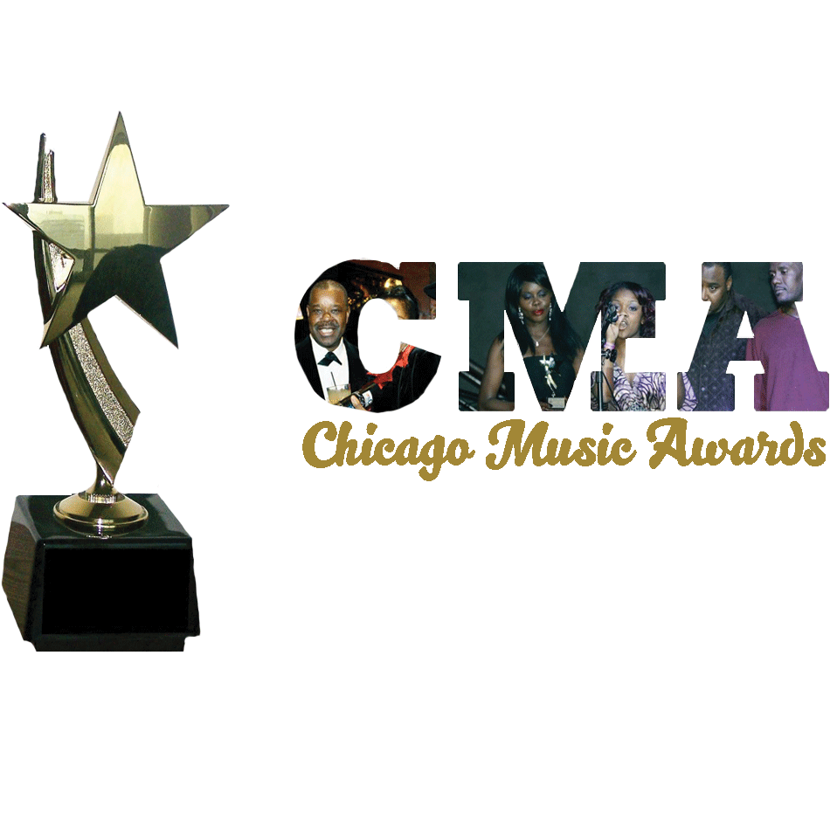
43rd ^{Annual} Chicago Music Awards (CMA)/Banquet Nomination Ballot
SUNDAY, DECEMBER 13TH, 2026, 6:00PM VIP ARRIVAL
The New Furama Ballroom, 2828 South Wentworth Avenue, Chicago, IL. 60616 VIP BANQUET/AWARDS TIX - $150 PER PERSON. Special limited early promo tix $950 table of 10 or $99 per person. Visit WWW.CHICAGOMUSICAWARDS.ORG or Eventbrite.

Dear Chicagoland Entertainers, Music Industry Members and Experts:

Thanks for your years of contributions in helping us to select nominees for the Annual Chicago Music Awards (CMA). Again, you are called upon to participate in the selection of nominees for this 43RD Annual CMA. If you are a new expert/entertainer, we welcome you!

Your decision must be based on entertainers who live within a 200-mile radius of Chicago for at least one year. Other determining factors include:
Music sales, Originality, Social relevance of material, Local/National performances, Quality of performances, Stage appearances, Social media impressions, and/or other attractions.
The Judging period is from DECEMBER 01st, 2025 to November 10th, 2026. Please enter your 1st and/or 2nd selections on the lines to the far right of each category;
Fill in your contact information and e-mail: chicagomusicawards@gmail.com no later than November 10th, 2026. Voting to select winners will start November 11th through December 5th, 2026. ONLY ONE NOMINATION BALLOT PER PERSON WILL BE ACCEPTED.

Nominator’s Name ___________________E-mail: _________________Company/Name/Affiliation: ________Area of Expertise_______.
Address: ______________City: _____ State_________ Phone: _____________ Subscribe to www.YouTube.com/irawma Signature:________________
 | Categories: | Voting category sponsored by: | Best of 2025/26 First choice: | Second choice
01 | Pop Entertainer of the Year
02. | R&B Entertainer of the Year
03. | Best New Entertainer | .
04. | Best Female Vocalist-
05. | Best Male Vocalist
06. | Best Reggae Entertainer
07. | Best Blues Entertainer
08. | Best Rock Entertainer
09. | Best Jazz Entertainer
10. | Best Spoken Word/Poet
11. | Best African/Afrobeat Entertainer
12. | Comedian of the Year
13. | Best Latin Entertainer
14 | Rev. Dr. Shelvin J. and Lucy Mae Hall Trust Award for  Best Gospel /Entertainer
15. | Best Country/Western Entertainer
16. | Best Hip Hop/Rap Entertainer
17. | Best Asian Entertainer
18. | Most Talented Entertainer ( under 19years old)
19. | Most Promising Entertainer
20 | Most Popular TV Music Show
21 | Most Popular Music Radio- DJ
22 | Best EDM (Electronic Dance Music) Entertainer
23 | Best House Music DJ
24 | Best Reggae/Dancehall DJ
25 | Best Afrobeat DJ
26 | Best Haitian Entertainer
27 | Best Steppers DJ
28 | Best Street/Club Party DJ
29. | Record Producer of the Year
30 | Songwriter of the Year
31 | Record Label of the Year
32. | Lifetime Award
33. | Martin’s International Award of Honor
.chicagomusicawards.org, email: chicagomusicawards@gmail.com, call (877) 973-4423 or (312) 427-0266. Thanks for your participation.

